# CS 255 System Design Document Template

## UML Diagrams

### UML Use Case Diagram

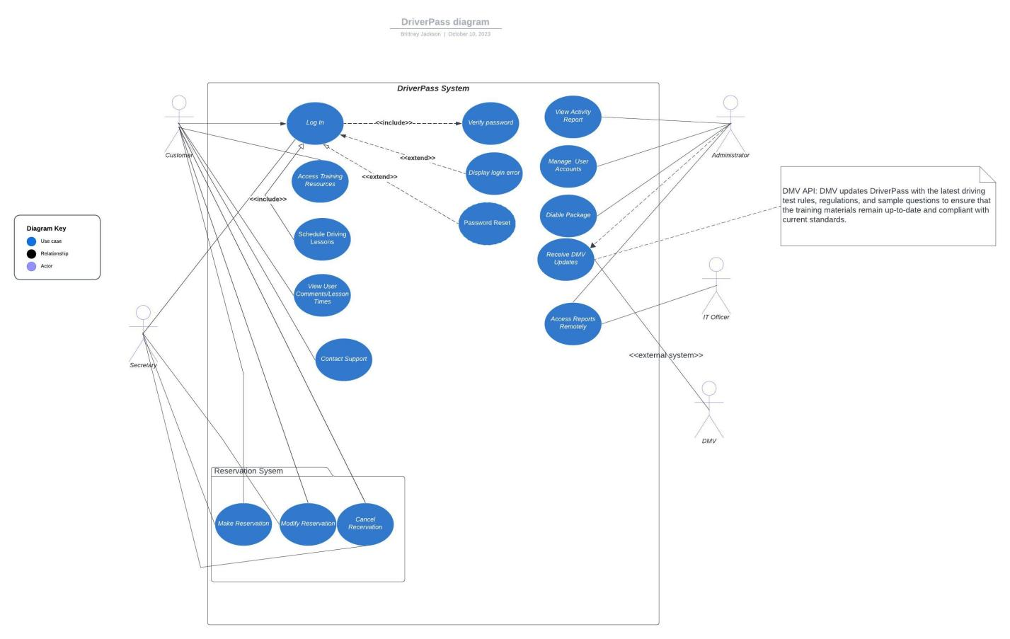

### *C:\Users\jacks\Downloads\Activity Diagram 1 (2).jpegActivity Diagram 1 (2)*UML Activity Diagrams: Log In and Manage User Accounts (Use cases)

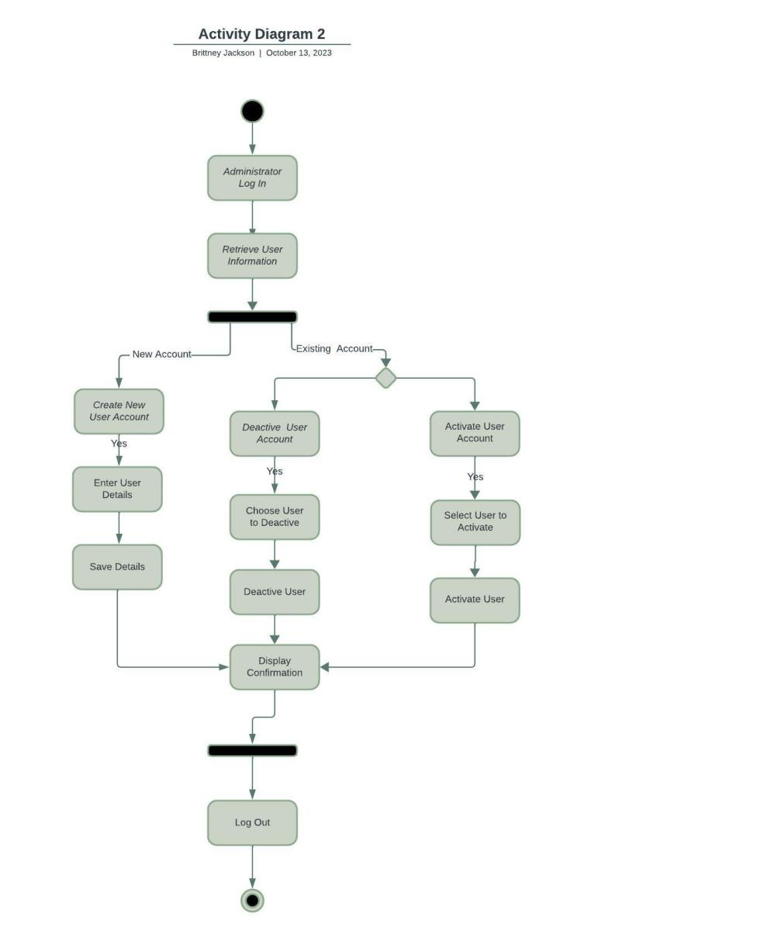

### UML Sequence Diagram

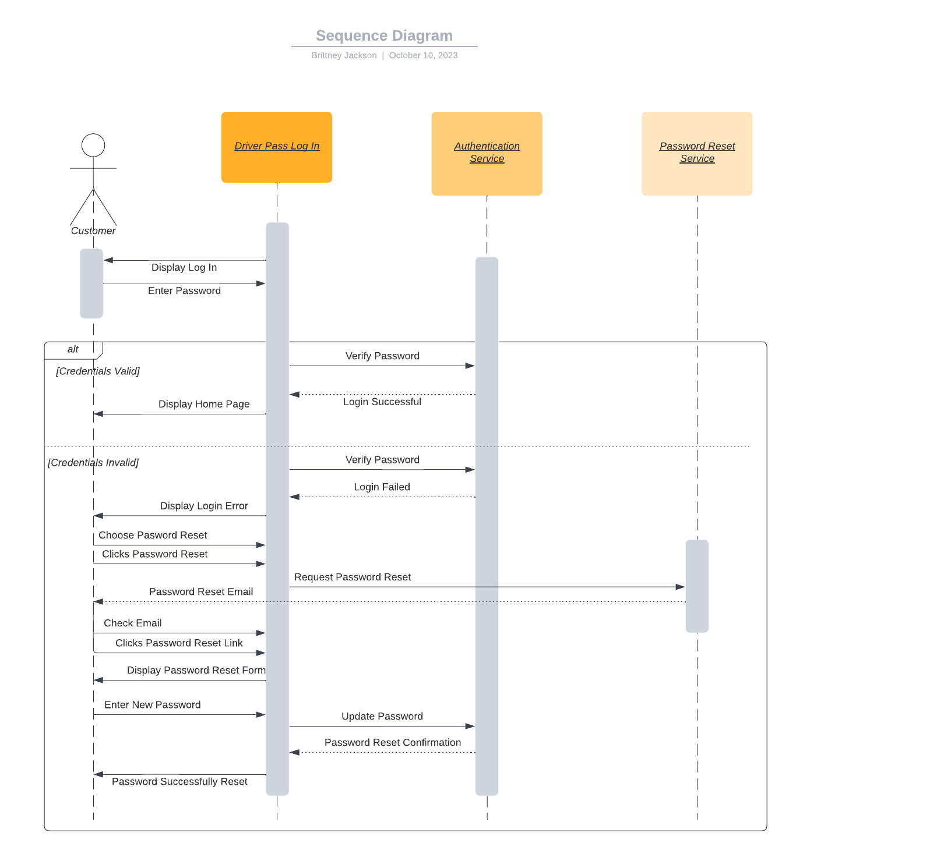

### UML Class Diagram

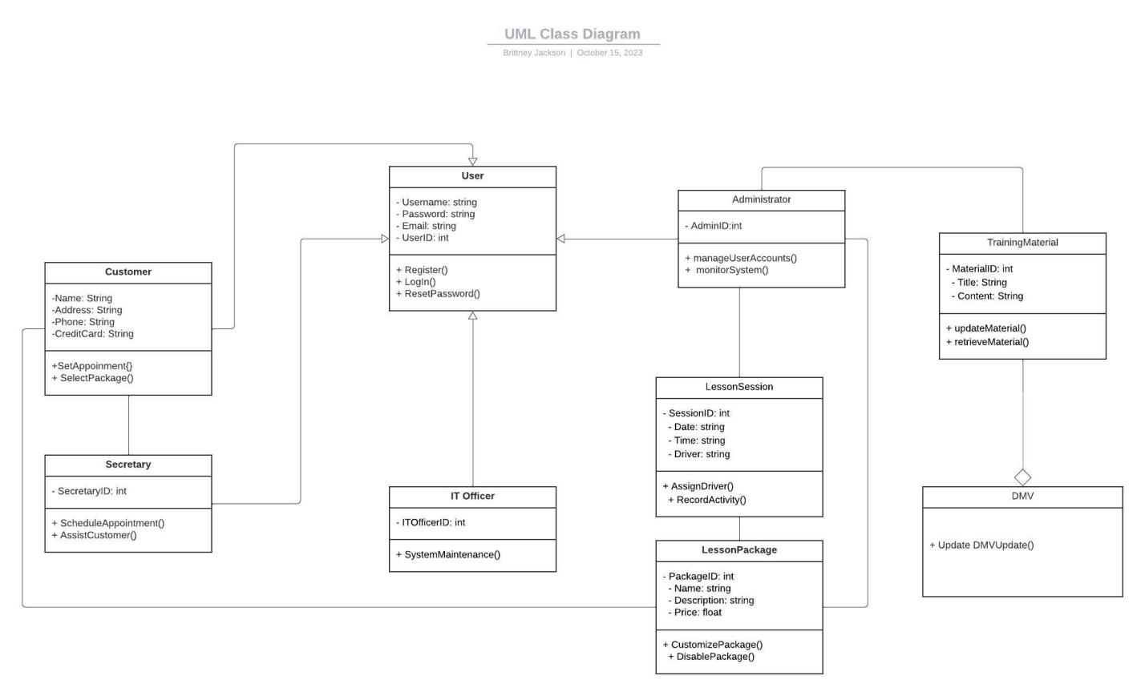

## Technical Requirements

*[Based on the diagrams you have created, describe the technical requirements of your system. These requirements should address the required hardware, software, tools, and infrastructure necessary for your system design.]*

Hardware Requirements:

* Robust server infrastructure for hosting system components.
* Dependable internet connectivity for seamless user access.
* Dedicated database server for secure data storage.
* Compatibility with various end-user devices.
* Security hardware (firewalls, intrusion detection systems, encryption) for data protection.

Software Requirements:

* Compatibility with common operating systems.
* Web server software for system hosting.
* Reliable database management system.
* Development frameworks and tools for web and database development.
* Security software (anti-virus, anti-malware) for system protection.

Tools and Infrastructure:

* Development environments for efficient software development.
* Remote access and monitoring tools for administrators and IT officers.
* Version control systems for managing software changes.
* Load balancers for high system availability.
* Backup and recovery systems for data protection.